AI Workflow Diagrams Explained with Real-World Examples

1. Sequential Workflow
Explanation: Steps execute one after another. Each step waits for the previous step to finish.
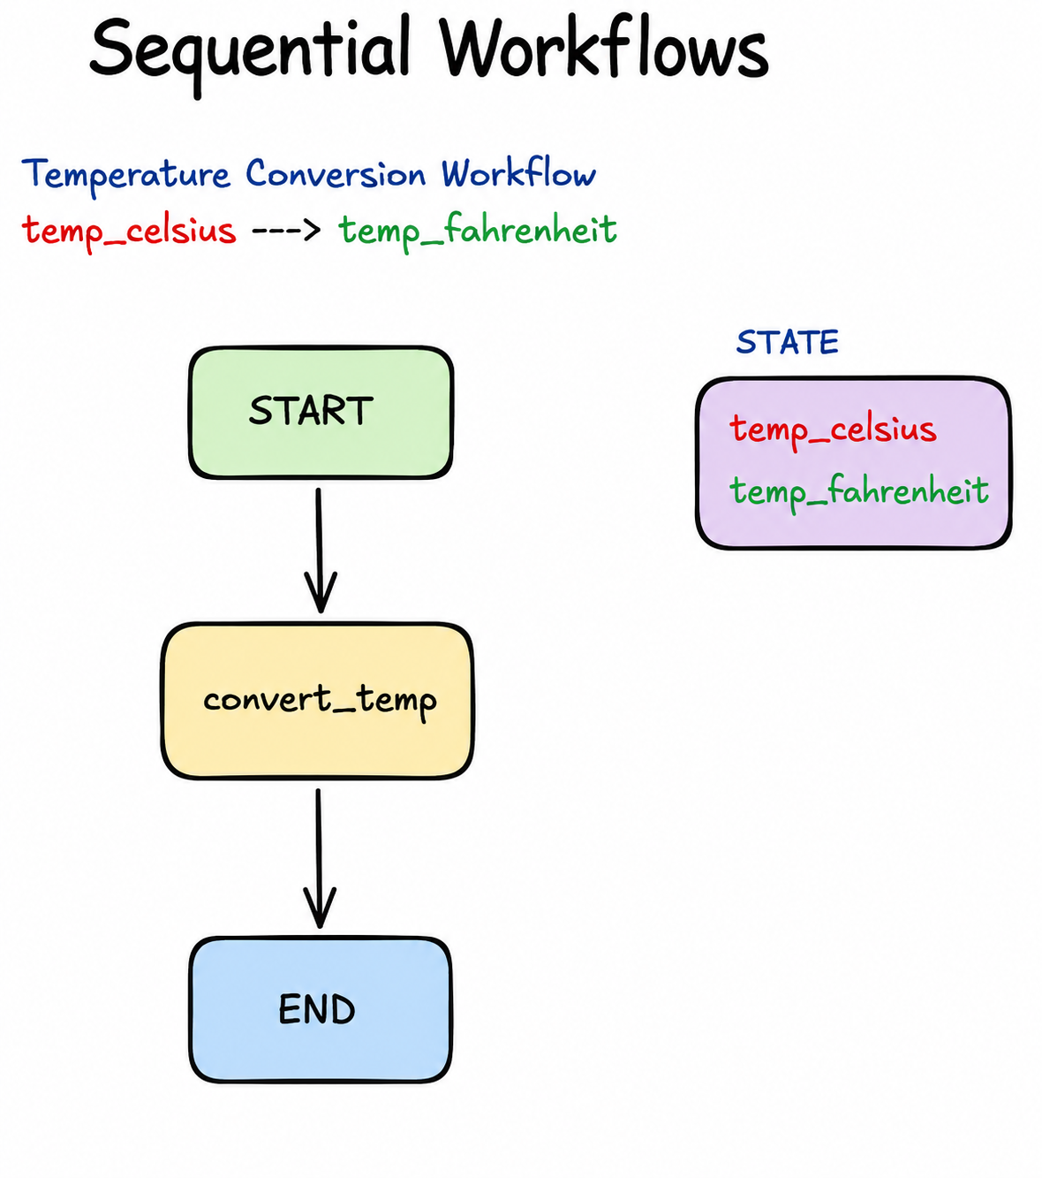
Real-world example: Making tea: Boil water → Add tea leaves → Pour into cup → Serve.
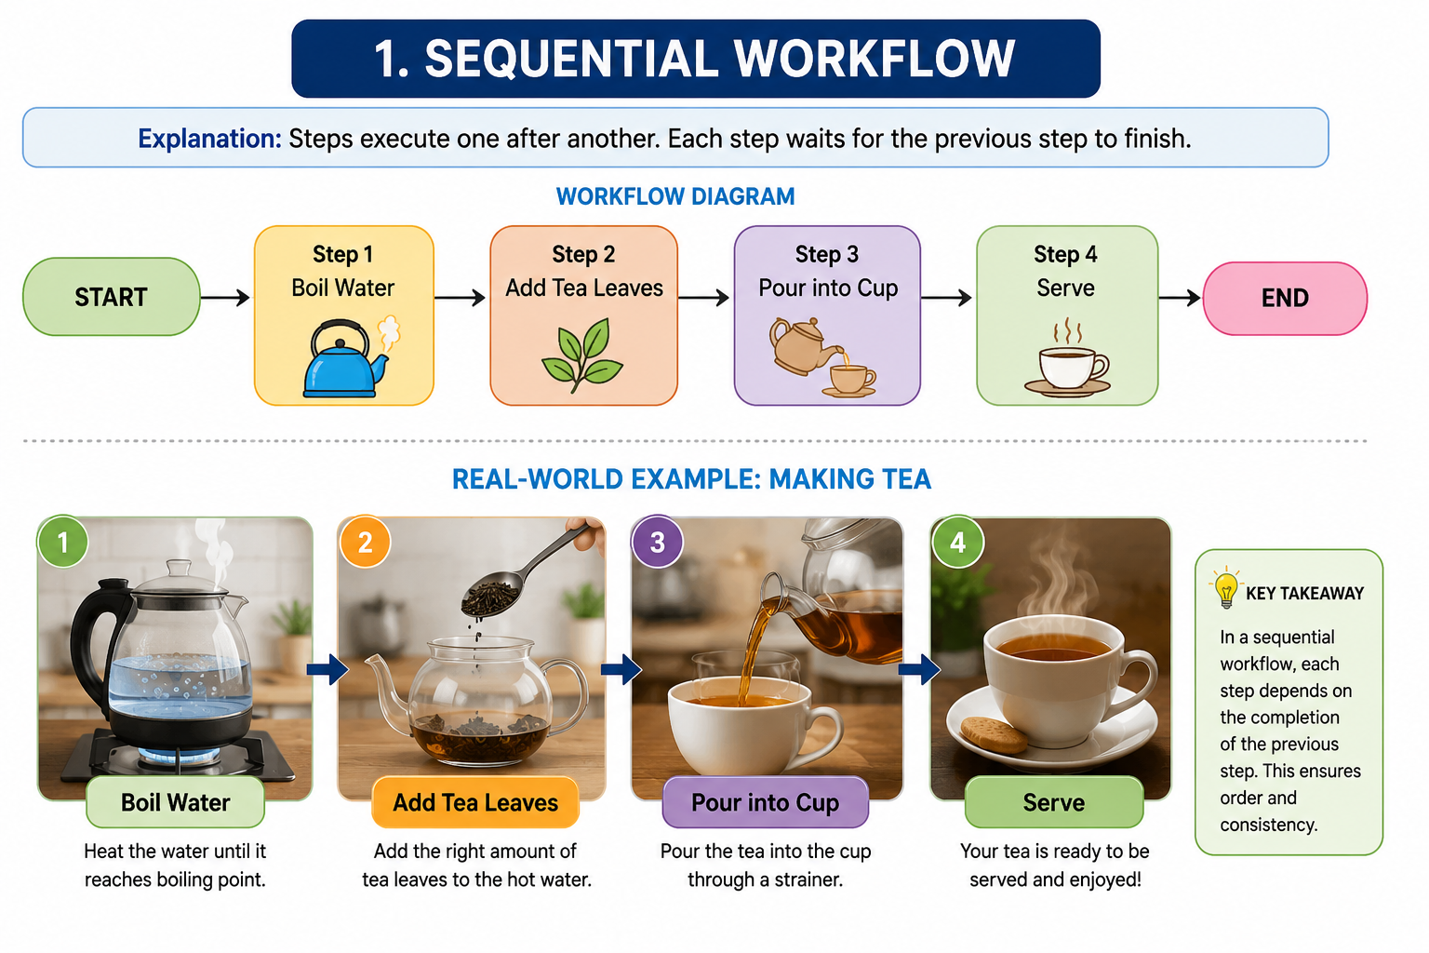

2. State-Based Workflow
Explanation: Data is stored and updated as the workflow progresses.
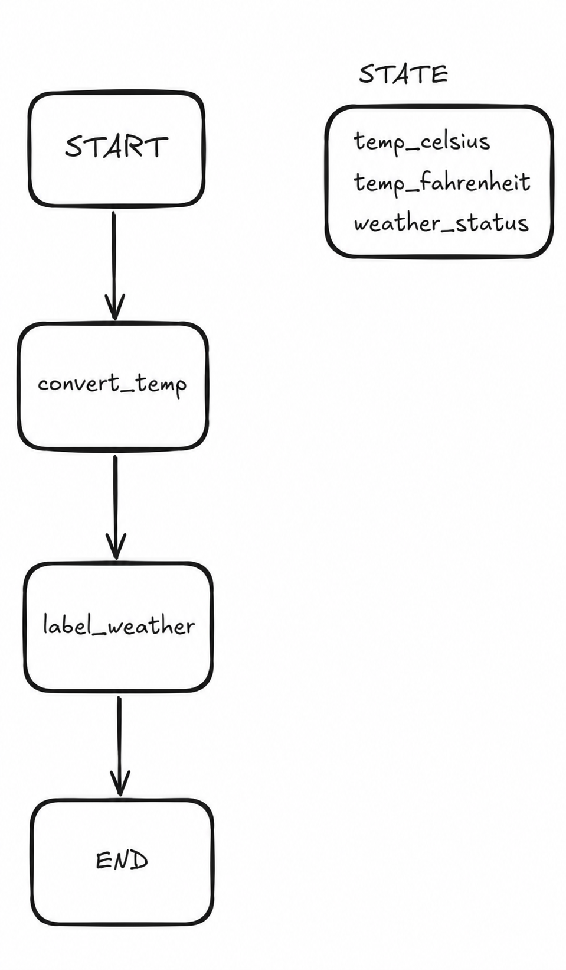
Real-world example: Weather app calculating temperature and then labeling it as Hot/Warm/Cold.
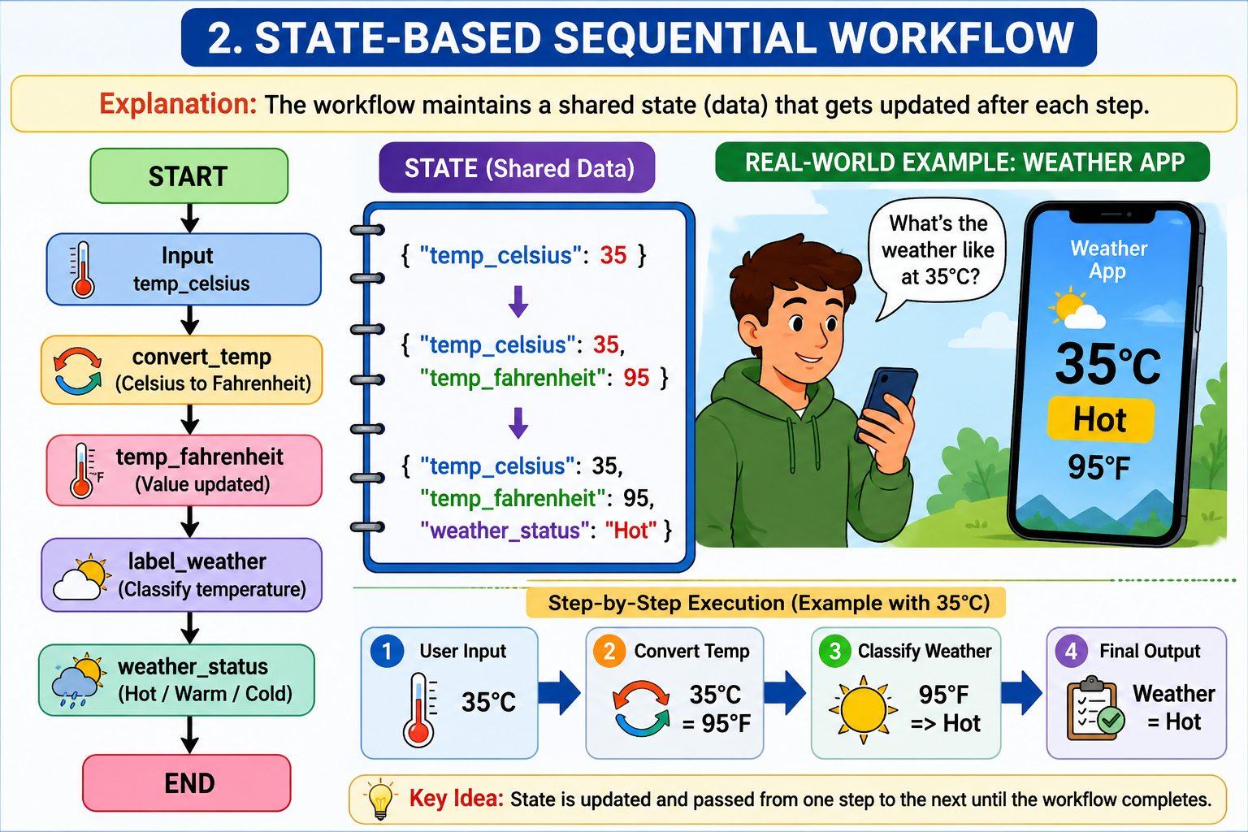

3. LLM QA Workflow
Explanation: A language model receives a question and returns an answer.
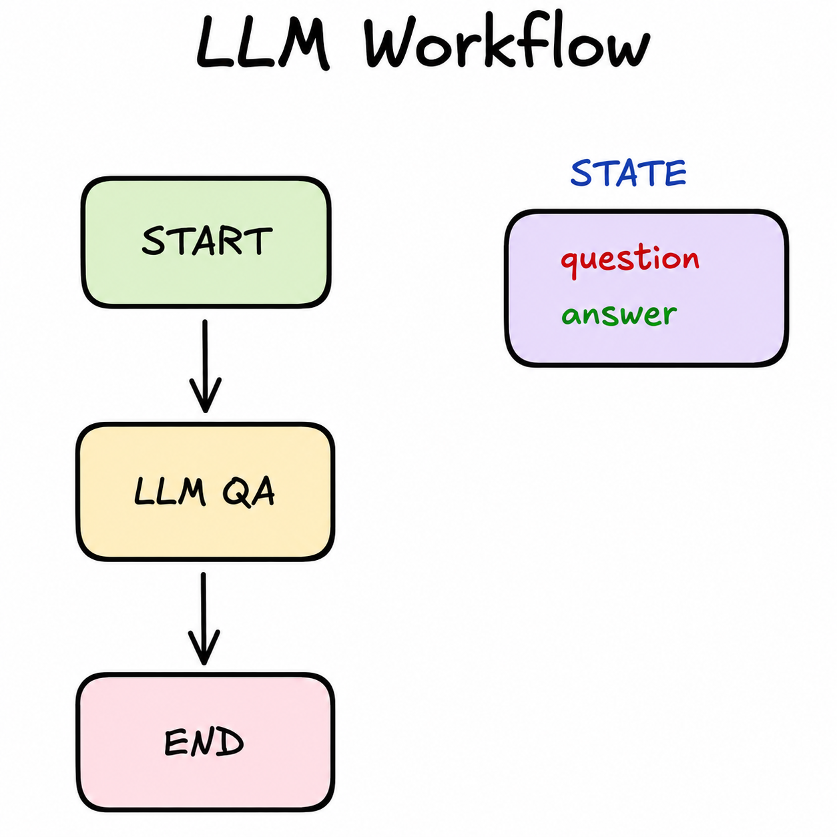
Real-world example: ChatGPT answering 'What is AI?'.

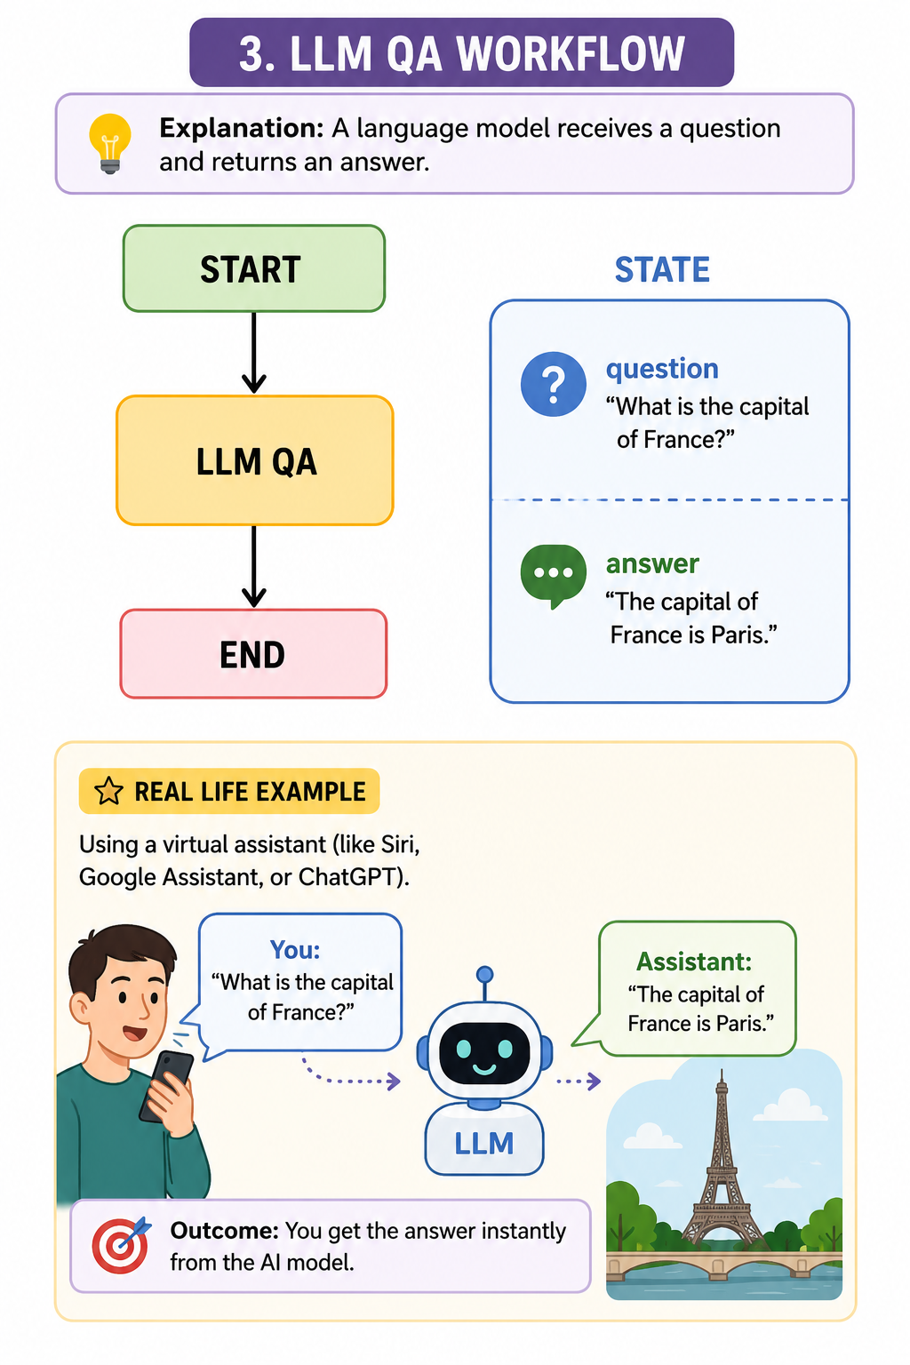

4. Prompt Chaining
Explanation: Output from one LLM step becomes input to the next.
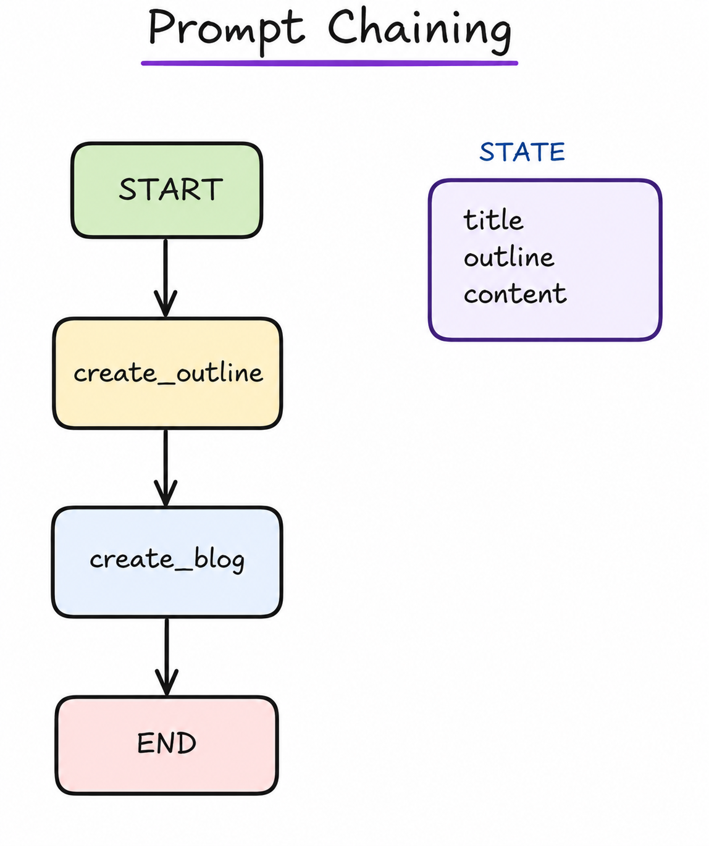
Real-world example: AI creates a blog outline and then expands it into a full article.
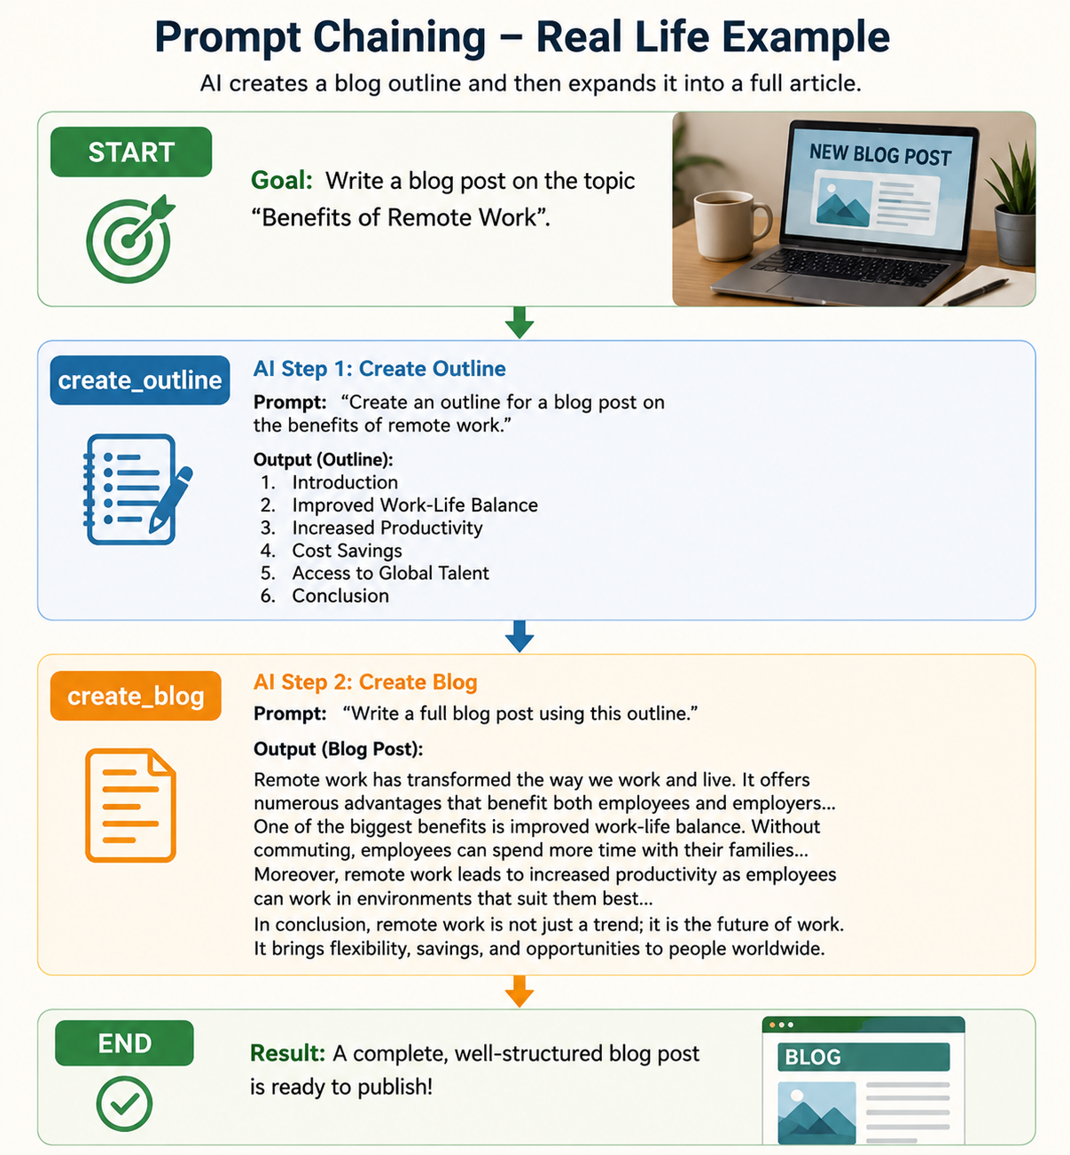

5. Parallel Workflow
Explanation: Several tasks run simultaneously.
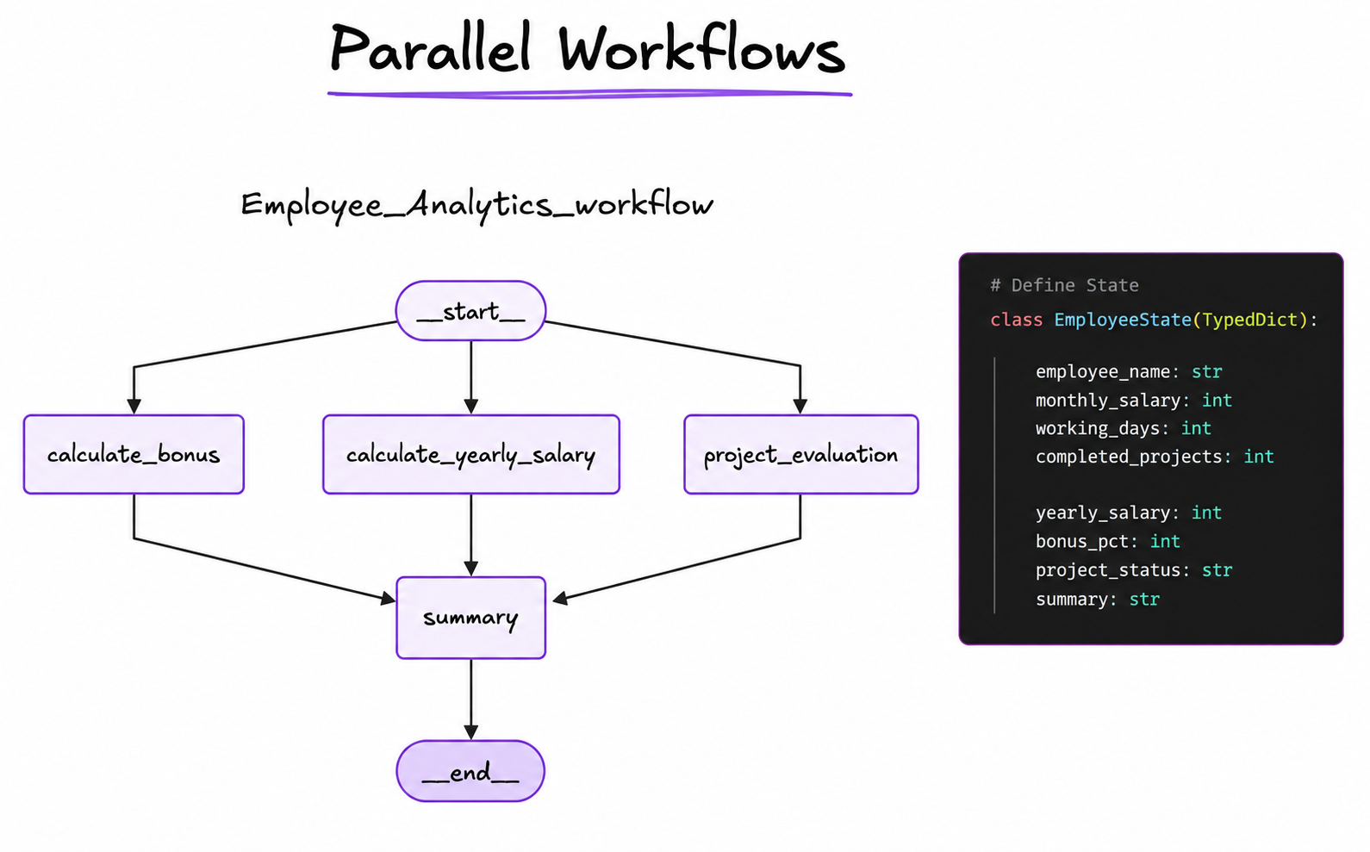

Real-world example: HR dashboard fetching attendance, salary, and performance at the same time.
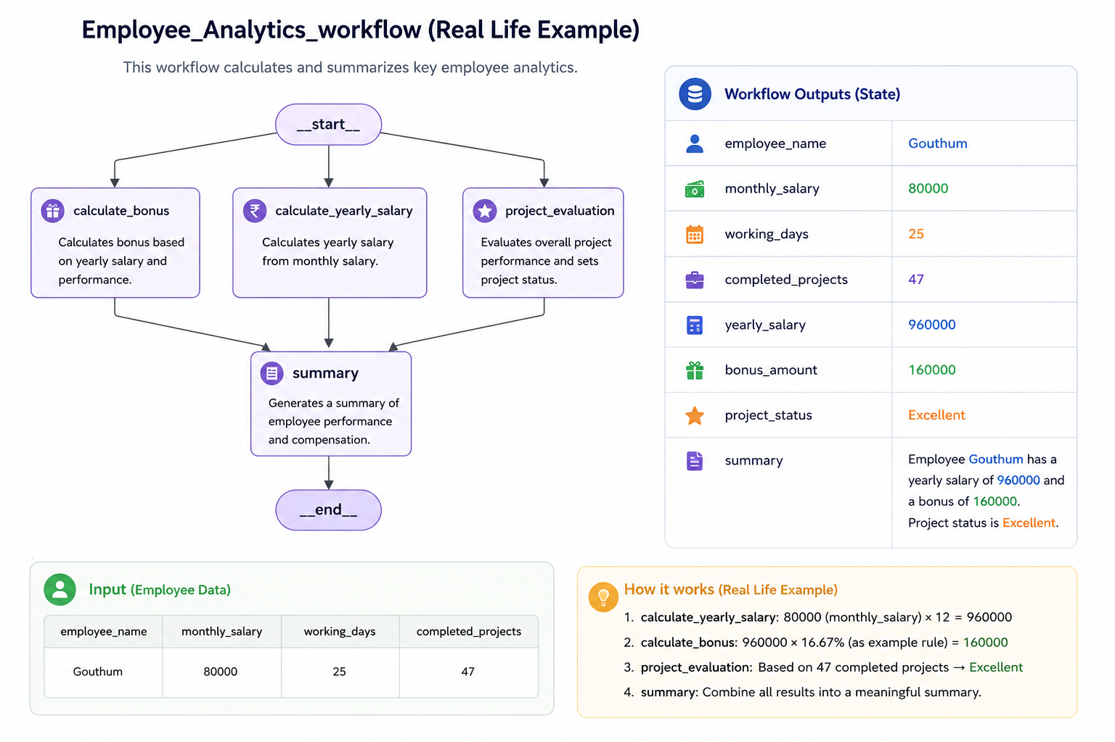

6. LLM Parallel Workflow
Explanation: Multiple AI agents work in parallel and combine results.
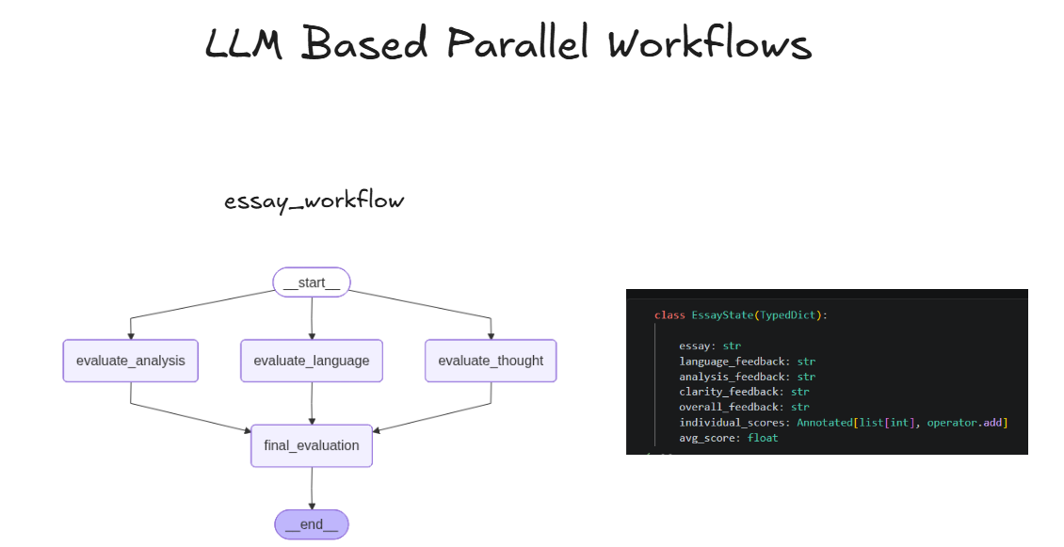
Real-world example: Financial, market, and news agents analyzing a company simultaneously.

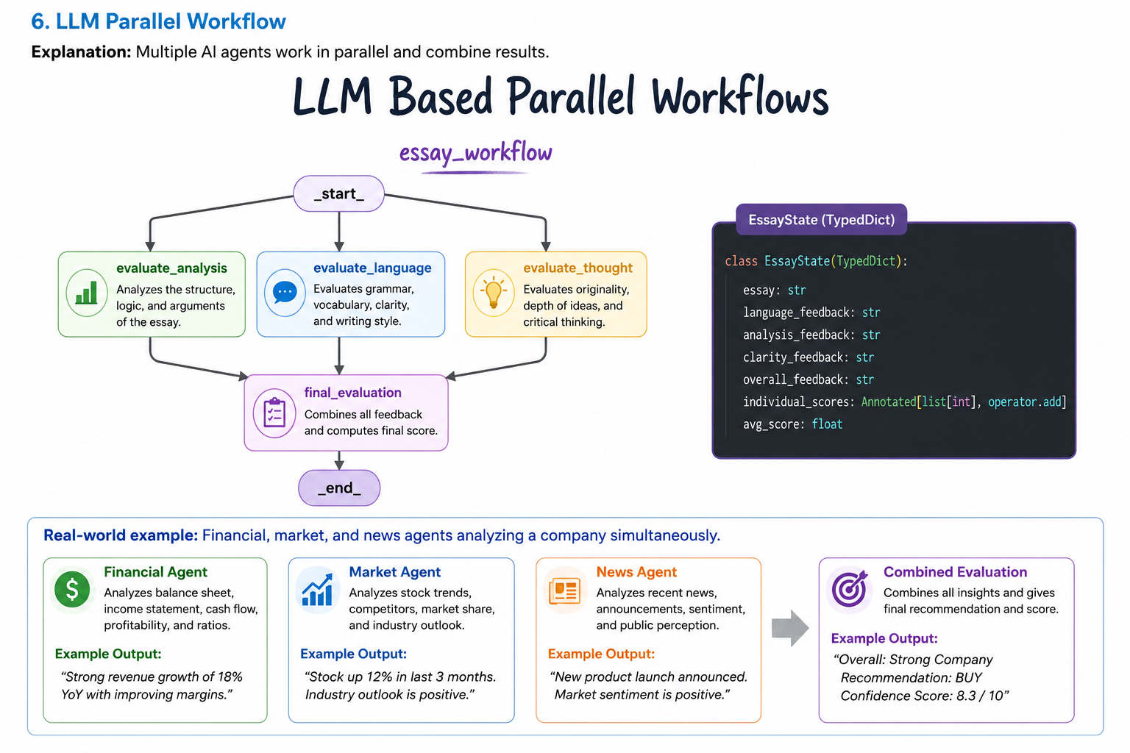

7. Conditional Workflow
Explanation: Different paths are taken based on conditions.
Real-world example: Spam filter deciding whether to publish, reject, or review a message.
Conditional workflow’s
Content Moderation System for a social media platform. It processes a user's text post,
evaluates it for spam, and conditionally routes it to be published, flagged for human review,
or automatically rejected.

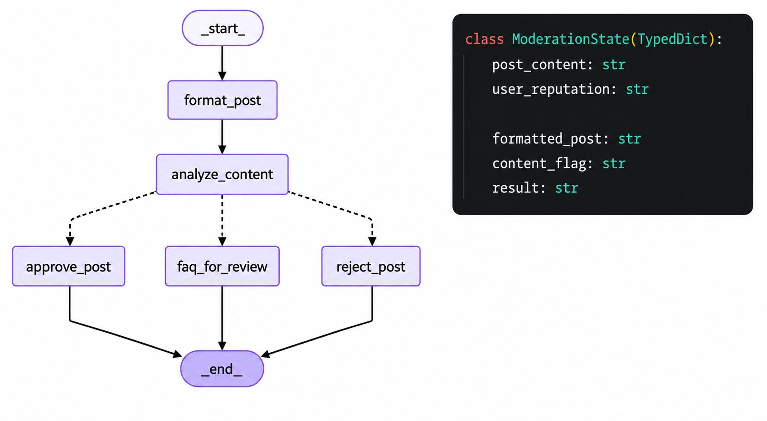

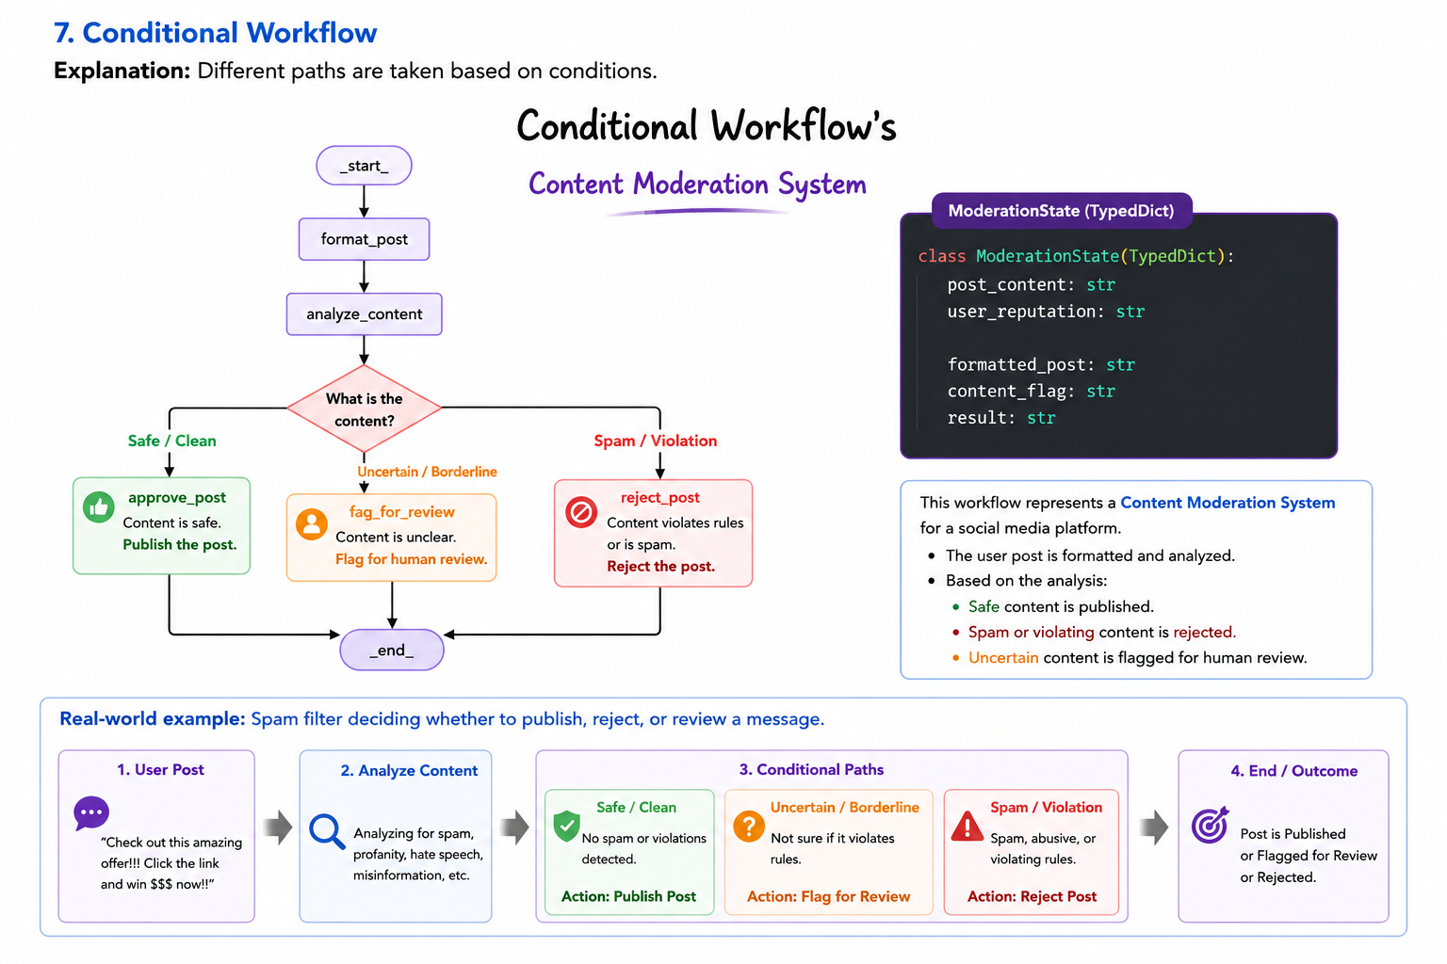

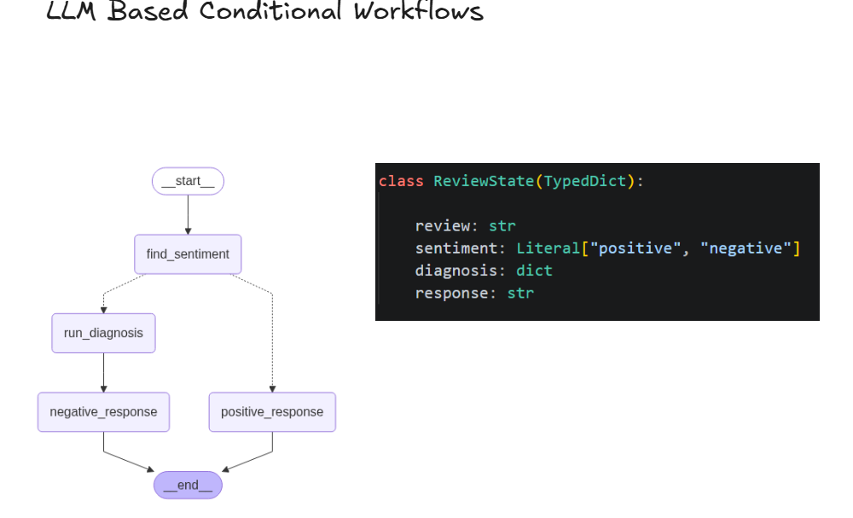

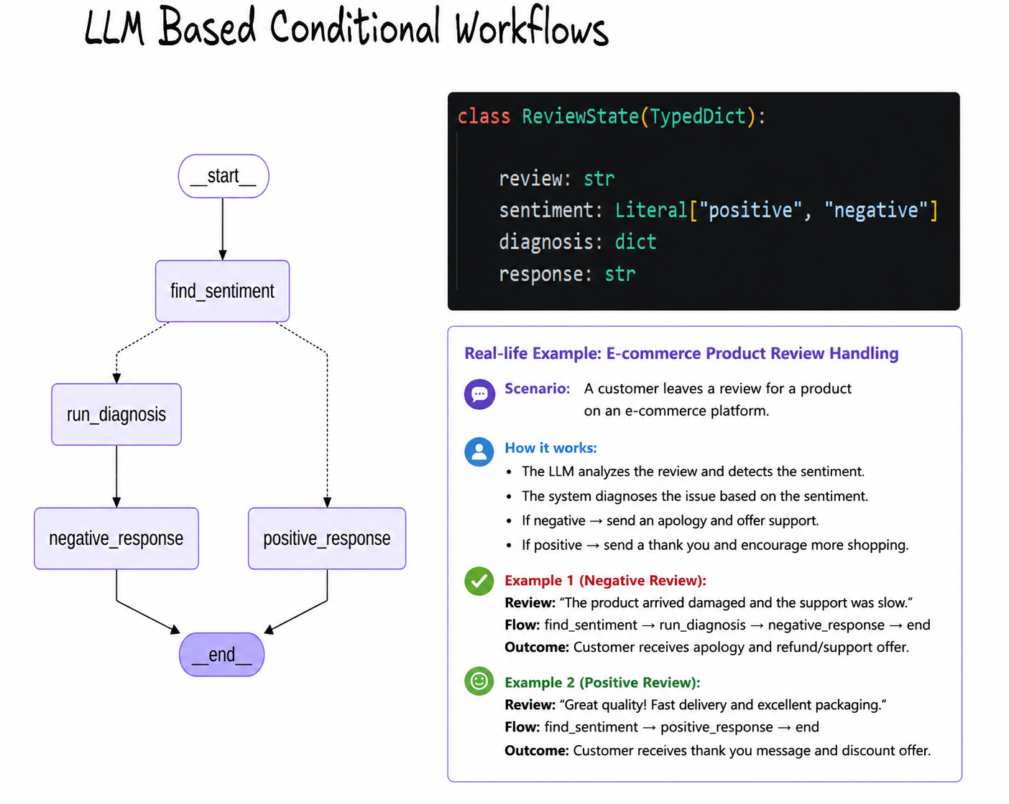

8. Iterative Workflow
Explanation: The workflow loops until quality criteria are met.
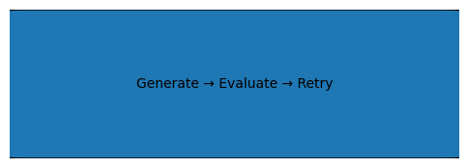
Real-world example: AI coding assistant repeatedly fixes code until tests pass.
